

**DOCTOR NAME**

Doctor Qualifications

**DOCTOR’S NOTE**

Dear __________________________,

I am writing to confirm that _____________________________ has been diagnosed with a ____________________________. To facilitate a full recovery of the patient, his/her recommended rest period is from ___________ to _____________. During this time, it is advised that he/she should refrain from attending work.

Your cooperation in helping to prevent the spread of illness is greatly appreciated.

Sincerely,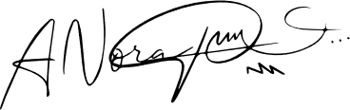

[Title/Position]  
[Clinic Name]



www.clinic.com



clinicname@email.com



123 Any Street, New York, USA



123-678-XXXX

DOCTOR NAME

Your Clinic Address

Your Clinic Phone No.

Doctor Qualifications

**DOCTOR’S NOTE**

Dear __________________________,

I am writing to confirm that ___________________________________ has been diagnosed with a ________________________________. To facilitate a full recovery of the patient, he recommended rest period is from ___________ to _____________. During this time, it is advised that he/she should refrain from attending work.

Your cooperation in helping to prevent the spread of illness is greatly appreciated.

Sincerely,

[Doctor's Sign]  
[Title/Position]  
[Clinic Name]